Finding factors associated with Anemia and Stunting for children under age 5 of Bangladesh: A study using BDHS 10 data
1. Data Information
The data is a subset of the 2010 Bangladesh demographic health survey (BDHS) data with 2283 respondents who have children of age five years or below. The survey was conducted year-round; however, no repetition is present, hence we can consider it as a cross-sectional one.
1.1. Response variables
Here we are considering two binary response variables:
- Anemia: Indicates whether the children have anemia or not
- Stunting: Indicates if the children have any history of getting stunted in last five years.
1.2 Independent variables
We have the following covariates and identifiers that we are going to use for this study.
Variable | Label | Type
caseid | Case identification
v001 | Cluster number
v002 | Household number
v013 | Age of mother in 5-year groups | Categorical
v024 | Region | Categorical
v025 | Type of place of residence | Categorical
v106 | Highest educational level | Categorical
v212 | Mother's age at 1st birth (in Year) | Continuous
v445 | BMI | Continuous
v456 | Hemoglobin level adjusted for altitude and smoking (g/dl - 1 decimal) | Continuous
b4 | Sex of child | Categorical
m18 | size of child at birth | Categorical
hw1 | Child's age in months | Continuous
cage | Children's age | Continuous
motherane | Mother's having anemia | Categorical
SES | Wealth index | Categorical
birth_size | RECODE of m18 (size of child at birth) | Categorical
food_access | Three square meals in the past 12 months | Categorical

Among these variables, for v456 and v445, the missing values were recorded as 999 and 9999. Hence, we replace them accordingly.

1.3 Descriptive Statistics Table by Anemia Status
Data are presented as mean (SD) for continuous measures, and % (frequency) for categorical measures.
Variable | Total (N=2239) | No (N=1069) | Yes (N=1170) | p-value
Age of Mother |  |  |  | <0.001
15-19 | 12% (269) | 9% (96) | 16% (187)
20-24 | 36% (806) | 35% (374) | 36% (421)
25-29 | 27% (605) | 29% (310) | 25% (293)
30-34 | 16% (358) | 17% (182) | 15% (176)
35-39 | 7% (157) | 7% (75) | 6% (70)
40-44 | 3% (67) | 3% (32) | 3% (35)
45-49 | 0% (0) | 0% (0) | 0% (0)
Missing | 0% (0) | 0% (0) | 0% (0)
Region |  |  |  | 0.009
Barisal | 11% (246) | 9% (96) | 12% (140)
Chittagong | 19% (425) | 19% (203) | 19% (222)
Dhaka | 17% (381) | 18% (193) | 15% (176)
Khulna | 11% (246) | 11% (118) | 12% (140)
Rajshahi | 12% (268) | 13% (139) | 11% (129)
Rangpur | 14% (314) | 12% (128) | 15% (175)
Sylhet | 17% (381) | 18% (193) | 15% (176)
Residence (Urban) | 30% (672) | 33% (353) | 28% (328) | 0.016
Education Level |  |  |  | 0.002
No Education | 19% (425) | 18% (193) | 19% (222)
Primary | 33% (740) | 31% (331) | 34% (398)
Secondary | 41% (918) | 42% (449) | 41% (480)
Higher | 7% (157) | 9% (96) | 5% (59)
Wealth Index |  |  |  | <0.001
Poorest | 23% (515) | 19% (203) | 26% (304)
Poorer | 20% (448) | 17% (182) | 22% (257)
Middle | 18% (403) | 18% (192) | 18% (211)
Richer | 19% (425) | 21% (224) | 17% (199)
Richest | 21% (470) | 24% (257) | 17% (199)
Age at First Birth | 18.0 (3.2) | 18.3 (3.3) | 17.8 (3.1) | <0.001
BMI | 21.0 (5.9) | 21.4 (6.1) | 20.7 (5.8) | 0.004
Hemoglobin-Mother(g/dL) | 121.0 (13.7) | 123.8 (13.3) | 118.5 (13.6) | <0.001
Sex of Child (Male) | 51% (1141) | 50% (535) | 52% (608) | 0.33
Birth Sizes |  |  |  | 0.74
Very Small | 5% (112) | 5% (54) | 5% (59)
Smaller than Average | 12% (268) | 13% (139) | 12% (140)
Average | 68% (1522) | 68% (728) | 68% (795)
Larger than Average | 13% (291) | 12% (128) | 13% (152)
Very Large | 2% (45) | 2% (21) | 1% (12)
Unknown/other | 0% (0) | 0% (0) | 0% (0)
Child Age in Month | 33 (16) | 38 (15) | 29 (16) | <0.001
Child Hemoglobin | 10.8 (1.3) | 11.8 (0.6) | 9.9 (0.9) | <0.001
Food Access (Access to food) | 80% (1791) | 82% (877) | 79% (924) | 0.074
Mother Anemia (Anemic) | 43% (964) | 35% (374) | 50% (585) | <0.001
SES |  |  |  | <0.001
Poor | 43% (963) | 37% (395) | 48% (561)
Middle | 18% (403) | 18% (193) | 18% (211)
Rich | 39% (873) | 45% (481) | 34% (398)
Birth Size Recode |  |  |  | 0.77
Very Small | 5% (112) | 5% (54) | 5% (59)
Small | 12% (268) | 13% (139) | 12% (140)
Normal | 82% (1837) | 82% (875) | 82% (960)
Unknown/other | 0% (0) | 0% (0) | 0% (0)

1.4 Descriptive Statistics Table by Stunting Status
Data are presented as mean (SD) for continuous measures, and % (frequency) for categorical measures.
Variable | Total (N=2239) | No (N=1462) | Yes (N=777) | p-value
Age of Mother |  |  |  | 0.50
15-19 | 12% (269) | 12% (175) | 14% (109)
20-24 | 36% (806) | 36% (526) | 35% (272)
25-29 | 27% (605) | 27% (395) | 26% (202)
30-34 | 16% (358) | 16% (234) | 15% (116)
35-39 | 7% (157) | 7% (102) | 7% (54)
40-44 | 3% (67) | 2% (29) | 3% (23)
45-49 | 0% (0) | 0% (0) | 1% (8)
Missing | 0% (0) | 0% (0) | 0% (0)
Region |  |  |  | 0.015
Barisal | 11% (246) | 10% (146) | 12% (93)
Chittagong | 19% (425) | 19% (278) | 19% (148)
Dhaka | 17% (381) | 16% (234) | 18% (140)
Khulna | 11% (246) | 13% (190) | 9% (70)
Rajshahi | 12% (268) | 13% (190) | 10% (78)
Rangpur | 14% (314) | 14% (205) | 14% (109)
Sylhet | 17% (381) | 16% (234) | 19% (148)
Residence (Urban) | 30% (672) | 33% (483) | 25% (194) | <0.001
Education Level |  |  |  | <0.001
No Education | 19% (425) | 15% (219) | 27% (210)
Primary | 33% (740) | 29% (424) | 40% (311)
Secondary | 41% (918) | 47% (687) | 31% (241)
Higher | 7% (157) | 9% (132) | 3% (23)
Wealth Index |  |  |  | <0.001
Poorest | 23% (515) | 17% (249) | 33% (256)
Poorer | 20% (448) | 19% (278) | 22% (171)
Middle | 18% (403) | 18% (263) | 18% (140)
Richer | 19% (425) | 20% (292) | 16% (124)
Richest | 21% (470) | 26% (380) | 10% (78)
Age at First Birth | 18.0 (3.2) | 18.3 (3.4) | 17.5 (2.8) | <0.001
BMI | 21.0 (5.9) | 21.5 (6.2) | 20.1 (5.1) | <0.001
Hemoglobin-Mother(g/dL) | 121.0 (13.7) | 121.6 (13.3) | 119.9 (14.5) | 0.005
Sex of Child (Male) | 51% (1141) | 53% (775) | 48% (372) | 0.030
Birth Sizes |  |  |  | <0.001
Very Small | 5% (112) | 4% (58) | 7% (54)
Smaller than Average | 12% (268) | 11% (161) | 15% (117)
Average | 68% (1522) | 69% (1009) | 66% (513)
Larger than Average | 13% (291) | 14% (205) | 11% (86)
Very Large | 2% (45) | 2% (29) | 1% (8)
Unknown/other | 0% (0) | 0% (0) | 0% (0)
Child Age in Month | 33 (16) | 32 (16) | 34 (15) | 0.006
Child Hemoglobin | 10.8 (1.3) | 10.8 (1.2) | 10.7 (1.3) | 0.003
Food Access (Access to food) | 80% (1791) | 84% (1228) | 73% (567) | <0.001
Mother Anemia (Anemic) | 43% (964) | 42% (614) | 45% (350) | 0.19
SES |  |  |  | <0.001
Poor | 43% (963) | 36% (526) | 55% (427)
Middle | 18% (403) | 18% (263) | 18% (140)
Rich | 39% (873) | 46% (672) | 26% (202)
Birth Size Recode |  |  |  | <0.001
Very Small | 5% (112) | 4% (58) | 7% (54)
Small | 12% (268) | 11% (161) | 15% (117)
Normal | 82% (1837) | 85% (1243) | 78% (606)
Unknown/other | 0% (0) | 0% (0) | 0% (0)

2. Research Questions:
- Primary we shall explore whether variables like mother’s history of having anemia, mother’s age and socio-economic status (SES) have significant associations with a child’s having anemia or getting stunted, which are believed to be typical risk factors.
- Additionally, we shall explore whether other variables like type of residences (urban/rural), gender or age of the child is related to a child’s having anemia or getting stunted.
3. Exploratory Data Analysis
3.1 Continuous predictors
Here we are considering five continuous predictors: v212, v445, v456, hw1 and cage. To explore whether the five continuous predictors exhibit meaningful differences between children’s having anemia or getting stunted, we first examined a series of boxplots (Figure 1). The distribution for all five variables is notably different for anemic and non-anemic groups, although it’s not that straightforward to interpret for v456 as there are many outliers. Similar trend is observable for Stunting.

Figure 1: Grouped Box plots of continuous predictors for anemia vs not anemia (a) and stunting vs not stunting (b)
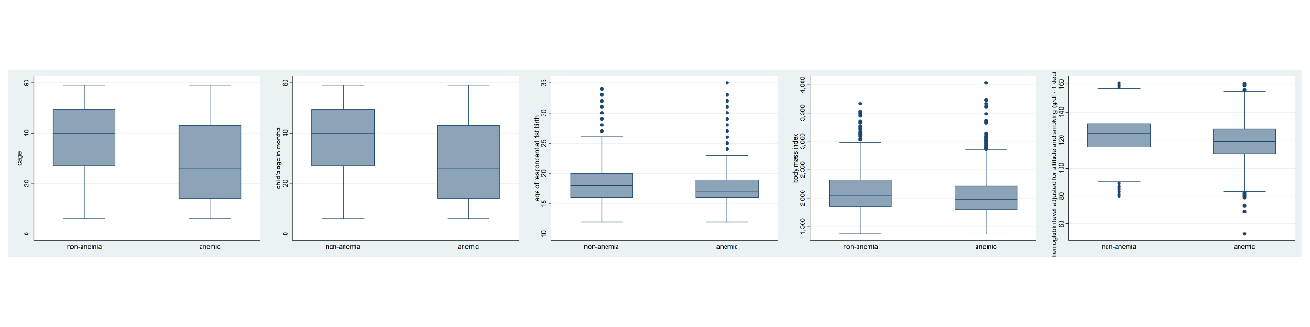
(a)
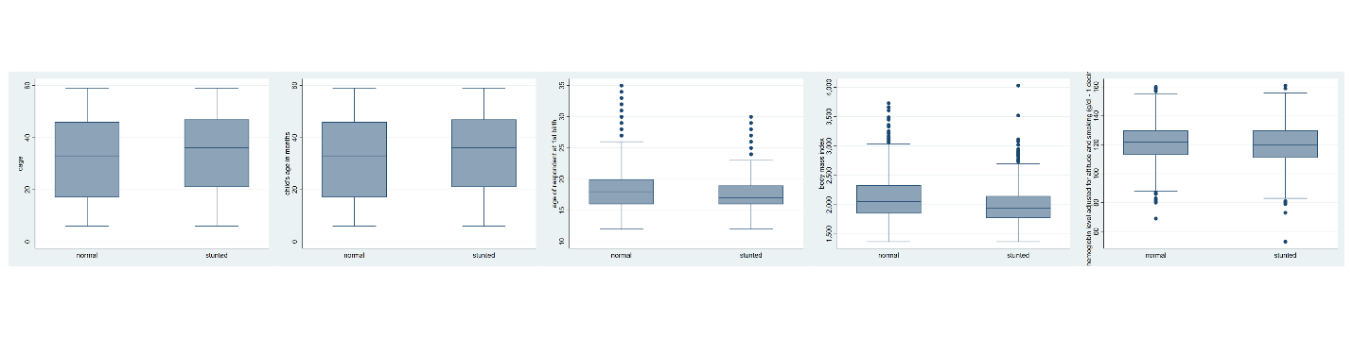
(b)

To further assess the strength of these associations, we conducted two sample t-tests for each predictor.
Table 2: T-test statistics and corresponding p-values for continuous predictors
Categorical  variable | Continuous  Variable | T statistic | p-value
Anemia | v212 | 3.479 | 0.001
 | v445 | 2.497 | 0.013
 | v456 | 1.614 | 0.107
 | hw1 | 13.868 | 0.000
 | cage | 13.876 | 0.000
Stunting | v212 | 6.002 | 0.000
 | v445 | 4.398 | 0.000
 | v456 | 0.086 | 0.932
 | hw1 | -3.221 | 0.001
 | cage | -3.215 | 0.001

From table 2, we can see both the response variables are significantly associated at 5% significance level with all the continuous variables due to having p-values smaller than 0.05, except for v456.

3.2 Categorical predictors
To examine the bivariate associations between anemia status and each categorical predictor, we conducted Pearson’s Chi-square tests, with the corresponding results summarized in Table 3. The analyses indicate that several demographic and socioeconomic variables—including age group, region, type of residence, educational level, Mother's having anemia, and SES—are significantly associated with anemia status at the conventional 5% significance level (all p < 0.05). Under a more flexible criterion, specifically the 10% significance level, access to three square meals in the past 12 months demonstrates a marginal association with anemia and may therefore be considered a potential predictor. Conversely, child-related characteristics such as sex of child, size at birth, and birth size do not show statistically significant associations, suggesting that biological factors at birth may play a more limited role in determining anemia status relative to broader socioeconomic conditions.
Table 3. Pearson’s Chi-squared test results for associations between categorical predictors and anemia status.
Variable | Test Statistics | Df | p-value
Age in 5-year groups | 30.4193 | 6 | 0.000
Region | 16.0705 | 6 | 0.013
Type of place of residence | 6.0313 | 1 | 0.014
Highest educational level | 14.6641 | 3 | 0.002
Mother's having anemia | 56.3612 | 1 | 0.000
SES | 36.6885 | 2 | 0.000
Sex of child | 0.8606 | 1 | 0.354
Size of child at birth | 3.1194 | 5 | 0.682
RECODE of m18 (size of child at birth) | 1.1691 | 3 | 0.760
Three square meals in the past 12 months | 3.2704 | 1 | 0.071

Pearson’s Chi-square tests were also conducted to assess the bivariate associations between stunting status and the same set of categorical predictors, with results reported in Table 4. Unlike anemia, stunting appears to be associated with both socioeconomic factors and child-specific biological characteristics. Educational level, wealth index, SES, region, and access to three square meals all demonstrate statistically significant associations with stunting at the 5% significance level. In addition, sex of child, size at birth, and RECODE of m18 (size of child at birth) are also significantly associated with stunting (p < 0.05), suggesting that early-life biological growth factors may play an important role in stunting outcomes. In contrast, age in 5-year groups and mother's having anemia do not demonstrate a statistically significant association, indicating that age variation and mother’s anemia status may not substantially explain differences in stunting prevalence within this sample.

Table 4. Pearson’s Chi-squared test results for associations between categorical predictors and stunting status.
Variable | Test Statistics | Df | p-value
Age in 5-year groups | 5.8184 | 6 | 0.444
region | 16.7526 | 6 | 0.010
Type of place of residence | 14.1846 | 1 | 0.000
Highest educational level | 128.0222 | 3 | 0.000
Mother's having anemia | 1.6925 | 1 | 0.193
SES | 99.5535 | 2 | 0.000
Sex of child | 5.0064 | 1 | 0.025
Size of child at birth | 25.4657 | 5 | 0.000
RECODE of m18 (size of child at birth) | 20.0896 | 3 | 0.000
Three square meals in the past 12 months | 42.3549 | 1 | 0.000

